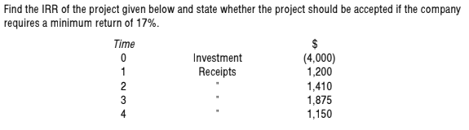
(Marks 10)
Question. 02
A company is considering two mutually exclusive options, option A and option B. The cash flows for each would be as follows.
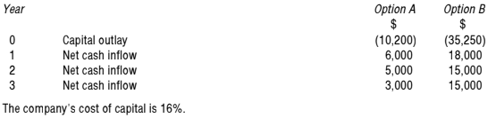
Required:
Evaluate & suggest company that which project should be undertaken. (Marks 10)

